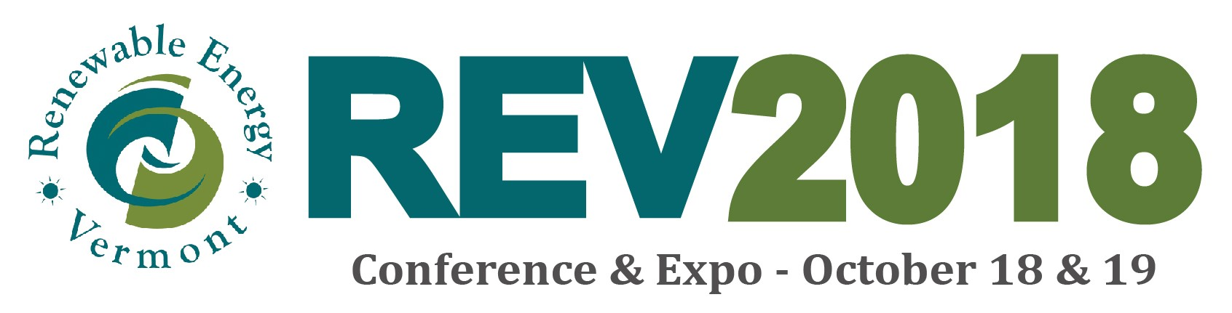
High Meadows Fund Reduced-Cost* Ticket Form
*Tickets are $30 for the 2-day event. Upon approval, we will send you payment information.
Complete this form and email to: info@revermont.org by Wednesday, September 12th. We will notify the selected attendees by Wednesday, September 19th. The Women in Energy Luncheon and Solar Energy International Training are not eligible to be covered by this scholarship.

Event Information
REV2018 – REVitalize: Transforming Energy Further, Faster, Together
Doubletree by Hilton (formerly the Sheraton Hotel), So. Burlington, VT
8:00 am – 7:00 pm Thursday, October 18
8:00 am – 12:30 pm Friday, October 19
www.revconference.org
Contact Information
Name _________________________________________________________________________
Organization/ Company ___________________________________________________________
Mailing Address _________________________________________________________________
Address Line 2 __________________________________________________________________
Phone ___________________________ Email _______________________________________
Are you a member of the following? If so, please specify.
◻ Regional Planning Commission __________________________________________________
◻ Town Energy Committee _______________________________________________________
◻ Town Planning Committee ______________________________________________________
◻ Legislature (constituency represented) ____________________________________________
◻ Faith-Based organization _______________________________________________________
If none of the above, why are you hoping to attend this conference? ______________________
Please answer the following questions.
- What is your interest in renewable energy?
- Is there a particular project or technology you are interested in?
- What do you hope to learn at RE2018?
- If applicable, what is your energy vision for Vermont?
- Have you ever opposed an energy project and if yes, why?

