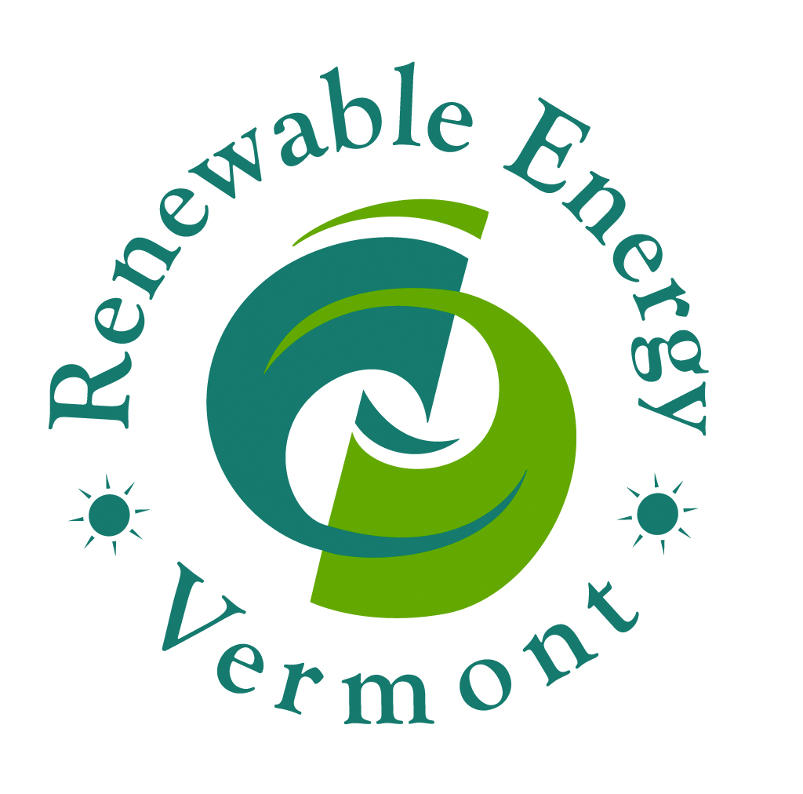
Operations Manager
Position Opening

Renewable Energy Vermont (REV), a non-profit, non-partisan trade association, represents businesses, non-profits, utilities, and individuals committed to reducing our reliance on fossil fuels by increasing clean renewable energy and energy efficiency in Vermont. Vermont’s clean energy economy supports at least 18,800 sustainable jobs at 2,519 businesses, representing approximately 6% of Vermont’s workforce. Together, we will achieve 100% total renewable energy (electric, thermal, transportation).

Position Description:
REV seeks a team-oriented person to implement a broad array of membership services, events, fundraising, and operations work. The Operations Manager will oversee organizing REV’s annual conference & expo – now in its 20th year as the premier comprehensive renewable energy event in northern New England, attended by more than 500 business, community, and government leaders. The Operations Manager also oversees all logistics for other REV events including Board meetings, annual membership meeting, legislative reception, webinars and more. The Operations Manager oversees REV membership recruitment, retention, and services – including workforce development training. The position assists the Executive Director with board management and special projects. The position is primarily responsible for REV’s operations with daily tasks including, office and data management, coordinating the organization’s finances, and providing administrative assistance to the Executive Director.

Qualifications:
- Passion for achieving Vermont’s clean energy future
- Bachelor’s Degree
- Very strong organizational skills and attention to detail
- Ability to work autonomously and as a team-player within a fast-paced environment
- Skilled at problem-solving regarding information technology
- Experience with Quick Books, budgeting and financial coordination
- Demonstrated ability to build and maintain relationships with a wide array of people and organizations
- Persuasive written and verbal communication skills
- Experience with digital media and graphic design with Adobe Create Cloud Products preferred
- Flexibility and humor

To apply, please send a resume, cover letter, and brief writing sample to rev2020@revermont.org. Candidates should include salary requirements in their cover letter. Position open until filled.

Join our team if you want to collaborate with fun co-workers and association members who share a passion for reducing climate pollution through entrepreneurial innovation. Full time REV team members receive a benefit plan including flexible leave, matching retirement IRA, cafeteria health benefits, flexible work schedule, and teleworking (up to 2 days a week).

